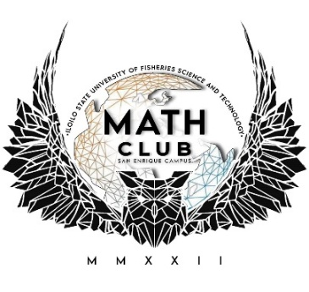

MATH CLUB

ORGNIZATION

**CONSTITION AND BY-LAWS**

Math Club of Iloilo State University of Fisheries Science and Technology Constitution & By-Laws

**Preamble**

Section 1: The purpose of the Math Club of ISUFST- San Enrique Campus shall be to promote the subject of mathematics, to increase participation in mathematics at all levels, and to provide a framework for persons to organize and conduct education, research, and other activities related to mathematics.

**Article I: Name**

Section 1: The name of this organization shall be Math Club of ISUFST- San Enrique Campus. Math Club of ISUFST- San Enrique Campus may be abbreviated to Math Club for the purposes of this Constitution and other events as deemed appropriate or convenient.

**Article II: Membership**

Section 1: Membership is limited to students currently enrolled at ISUFST- San Enrique Campus, including graduate students, undergraduate students, and high school students.

Section 2: Members must have had a minimum grade point average of 2.0 in the prior semester (not including any fall intercession, spring intercession, summer intercession, or summer semester) with the exception of incoming freshmen, students transferring in from another university, and foreign exchange students.

Section 3: An individual must attend at least 2 meetings in one semester to become a member of Math Club. Upon appearing at the second meeting, the individual is considered a member. To maintain membership, a member must attend at least 2 meetings per semester (not including any fall intercession, spring intercession, summer intercession, or summer semester). At the end of each semester, all members who have not attended at least two meetings during the given semester, will at that point no longer be considered members. To regain membership, the individual must attend 2 meetings during a given semester (not including any fall intercession, spring intercession, summer intercession, or summer semester), as if they were never a member to begin with.

Section 4: Any member may voluntarily demit from the Math Club at any time for any reason, per the Student Government Organization (ISUFST- San Enrique Campus Forms, Criteria for Registration, Section 4.2).

**Article III: Structure**

Section 1 - Advisor: In accordance with Student Organizations Guidelines set by Student Activities (page 3), Math Club shall have an advisor that is a full-time faculty member or full-time administrator.

Section 1.A: The advisor’s term shall be indefinite, ending only when the current advisor is unwilling to fulfill this role or is deemed ineffective by the appropriate member of Student Activities.

Section 1.B: In accordance with Student Organizations Guidelines set by Student Activities (page 4), if the Math Club deems that the advisor is ineffective, all issues shall be discussed with Student Activities.

Section 2 – Executive Committee: Math Club shall have an executive committee consisting of 5 officers, namely, President, Vice President, Secretary, Treasurer, and Student Government Association Representative. The executive committee is tasked with handling the administrative responsibilities of Math Club, satisfying reasonable expectations held by members of Math Club, and fostering communication between Math Club and the campus community.

Section 2.A: Tasks associated with the aforementioned duties of the executive committee shall be delegated amongst all officers at the discretion of the President and Adviser.

Section 2.B: Only the President and Adviser have the authority to call Math Club meetings.

Section 2.B: Only Math Club members that have attended 3 meetings in the current semester are eligible for election to an office of the executive committee. Per the Student Government Organization (ISUFST – San Enrique Campus Organization Forms, Criteria for Registration, Section 4.4), at least 3 meetings must be called by the executive committee per semester (not including any fall intercession, spring intercession, summer intercession, or summer semester). Beyond this, the frequency, time, duration, and location of the meetings shall be determined at the discretion of the executive committee.

Section 2.C: A regular election shall be held approximately two weeks prior to the spring commencement ceremony to determine the officers for the executive committee. The term of office begins at the start of the following Fall semester and ends at the conclusion of the next Spring semester.

Section 2.D: For vacancies, the President’s office may be filled by the Vice President. The Vice President’s office may be filled by the Treasurer. The Treasurer’s office may be filled by the Secretary. Officers are not required to move up to fill vacancies. Vacancies may not be filled in any other manner without conducting an election.

Section 2.E: Each member may only be regularly elected twice for a given position on the executive committee. Special elections are those held during an irregular time, usually resulting from the inability to fill a vacancy. Special elections do not count toward the election limit.

Section 2.F: If an officer of the executive committee fails to maintain membership status as defined in Article II, this shall result in the officer being removed from office.

Section 3 – Voting: Math Club will make decisions by voting on all substantive matters. The majority rules except for amendments to this constitution or a motion to remove an officer from the executive committee, which require a 2/3 vote of approval. All members are eligible to vote. Members are not required to be present at a meeting in order to cast a vote.

Section 3.A: A meeting must be called to order at the time votes are counted. Members may still change their vote prior to the start of the count, but not after.

Section 3.B: The counting of votes is not required unless requested by at least 1 member. Such a request must be made, at the latest, prior to the conclusion of the meeting in which the votes are counted.

Section 3.C: Any vote resulting in a tie shall be broken by the advisor casting a vote. Otherwise, the advisor does not vote.

**Article IV: Amendments**

Section 1: Any member expressing concern with the ambiguity of any statement made in this constitution can request that the executive committee issue a clarification. The executive committee must be unanimous in its clarification. If the executive committee is unable to be unanimous in its interpretation, a clarifying amendment(s) shall be put to a vote. In the event that the proposed amendment(s) cannot pass with 2/3 vote, then the advisor of Math Club shall make the final decision as to the correct interpretation.

Section 2: No part of this constitution shall be in violation of any university policy, state or federal law. Any member finding such a violation within this constitution shall report it directly to the Math Club Adviser, who shall have the authority to remove the clause without taking a vote.

Section 3: This constitution, effective on this 13th day of April, 2018, shall supersede all previous version of the Constitution and By-Laws for the Math Club of Shawnee State University. Ratified in the presence of: Instr. Zyra E. Gregorio (Math Club Adviser), John Paul A. Agulay (President), Jamaica Pearl Agujetas (Vice President), Kyla Dolor Dela (Secretary) and other Math Club Members.

**Article V: Membership Dues and Registration Fee**

Section 1: All first-year students participating in the Math Fest shall be required to pay a registration fee of ₱100.00. This fee is exclusive to first-year students, as they are the only members covered for participation in the Math Fest, the Math Club’s main annual activity.

Section 2: The registration fee shall serve two purposes:

a) As a registration fee for participation in the Math Fest.

b) As a contribution to the general fund of the Math Club to support club activities and projects.

Section 3: The Math Club shall be responsible for collecting the registration fees and maintaining a transparent record of all funds. The Treasurer shall provide a report of collected fees and expenditures related to the Math Fest during the Math Club’s regular meetings.

Section 4: The registration fee is non-refundable under any circumstances, except in cases explicitly approved by the Math Club officers.

**ARTICLE XI: EFFECTIVITY**

*Section 1*

These Constitution and Bylaws shall take effect upon the approval of Campus Administrator, Chair, Office of Student Affairs and Services, Student Affairs Coordinator, Adviser and the Officers of the organization.

Adopted this 28th day of August, 2024 at ISUFST-SAN ENRIQUE CAMPUS San Enrique, Iloilo, Philippines by the affirmative vote of the majority of officers.

Prepared and ratified by:

**JOHN PAUL L. AGULAY**

President

**JAMAICA PEARL AGUJETAS**

Vice President

**KYLA DOLOR DELA**

Secretary

**RIZA MAE SICANG**

Assistant Secretary

**HARRA DIWA**

Treasurer

**JOHN KEVIN MANERO**

Assistant Treasurer

**GEVIE CABANSAG**

Auditor

**KAREN FAITH PACU-IN**

Assistant Auditor

**NHER CORDERO**

Business Manager

**JHUN LANDRICK CANTILLAS**

Assistant Business Manager

**JM ABORDAJE**

P.R.O.

**JHON DAVID POBLADOR**

P.R.O.

**JEASRYNN KYLA PALMEROLA**

Muse

**RICHMOND ELIZARES**

Escort

**ZYRA E. GREGORIO**

Adviser, Math Club

**ISABEL F. BIANA**

Co- Adviser, Math Club

**INSTR. MARVIN P. SUBRIDA**

OIC, Office of the Student Support Center

Approved:

**ENGR. REX D. DIAZ, DIT**

Campus Administrator

**MATH CLUB OFFICERS**

**A.Y. 2025-2026**

**President:** John Paul Agulay

**Vice President:** Jamaica Pearl Agujetas

**Secretary:** Kyla Dolor Dela

**Asst. Secretary:** Riza Mae Sicang

**Treasurer:** Harra Diwa

**Asst. Treasurer:** John Kevin Manero

**Auditor:** Gevie Cabansag

**Asst. Auditor:** Karen Faith Pacu-in

**Business Manager:** Nher Cordero

**Asst. Bus. Manager:** Jhun Landrick Cantillas

**P.R.O: 1.** JM Abordaje

**2.** Jhon David Poblador

**Muse:** Jeasrynn Kylla Palmerola

**Escort:** Richmond Elizares

**Adviser:** Instr. Zyra E. Gregorio

**Co- adviser:** Instr. Isabel F. Biana

Approved by:

**MARVIN P. SUBRIDA, MILE**

OIC, SSC

**LIST OF OFFICIALLY ENROLLED FOUNDING MEMBERS**

1. Cantillas, Jhun Landrick E.
2. Elizares, Richmond T.
3. Manero, John Kevin P.
4. Dela, Kyla Dolor A.
5. Demoral, Cathleen Joy L.
6. Pacu-in, Karen Faith R.
7. Palmerola, Jeasrynn Kylla P.
8. Sequito, Roseshine P.
9. Agulay, John Paul L.
10. Cabansag, Gevie C.
11. Cordero, Nher P.
12. Gomito, Renn Kristian G.
13. Balcena, Jessa Mae A.
14. Diwa, Harra M.
15. Lico, Jane P.
16. Salas, Stella Joy M.
17. Sicang, Riza Mae A.
18. Bacor, Julius T.
19. Concepcion, John P.
20. Agujetas, Jamaica Pearl B.
21. Biana, Ivy P.
22. Ginete, Diana April P.
23. Roberto, Menchie V.
24. Lorca. Rachel Mae
25. Abaquita, Christy Kaye F.
26. Hombales, Angelica
27. Prion, Rina Jean
28. .Latawan, Stephanie
29. Palmares, Ramon Miguel
30. Pamonag, Jay
31. Sombrea, Mar Rico
32. Palabrica, Roy
33. Gonzales, Donald

**PROPOSED TARGET PLAN**

|  |  |  |  |
| --- | --- | --- | --- |
| **Date** | **Activity** | **Person Involved** | **Purpose** |
| March 2026 | Math Fest 2026 | Math Teachers, Math Club Officers, math majors, and all first year college students of ISUFST-SEC enrolled in A.Y. 2025-2026. | * To promote appreciation and enjoyment of mathematics through fun and challenging activities. * To provide opportunities for students to showcase their mathematical skills. * To strengthen camaraderie among students, teachers, and the school community through mathematics- related events. |

**ACCOMPLISHMENT REPORT**

|  |  |  |  |  |  |
| --- | --- | --- | --- | --- | --- |
| **Date** | **Activities** | **Person Involved** | **Venue** | **Sponsoring Agency** | **Remarks** |
| April 24-25, 2025 | Math Fest 2025 Celebration | Math Teachers, Math Club Officers, math majors, and all first year college students of ISUFST-SEC enrolled in A.Y. 2024-2025. | ISUFST-SEC, Civic and Cultural Center | Math Club | ACCOMPLISHED |

The Math Club successfully conducted the celebration of Math Fest 2025 with on April 24-25, 2025 at ISUFST-SEC. The event was spearheaded by the Math Club officers together with the club adviser, with the support of the campus administrator, teachers, and student facilitators. The activity aimed to foster camaraderie, teamwork, and creativity among students while promoting appreciation of mathematics in diverse and enjoyable ways.

The celebration featured a variety of engaging activities that highlighted both academic and non-academic talents. Students showcased their artistry through the **Banner Making Contest**, while creativity and rhythm were emphasized in the lively **Math Dance Competition**. University spirit and unity were further expressed in the **Cheers and Yells Contest**, which brought together different groups in friendly competition. To cater to the interests of e-sports enthusiasts, the **Mobile Legends: Bang Bang Tournament** was organized, drawing large student participation. Traditional games were also revived with the inclusion of **Laro ng Lahi**, promoting teamwork and cultural appreciation. Adding fun and wit, the **Search for Messter and Mess Mathematician 2025** provided a platform for students to express both intelligence and personality, while the **Bingo and Color Games** added excitement and entertainment for all attendees.

The culminating part of the Math Fest was the Awarding Ceremony, where winners from different contests were recognized and rewarded with certificates and cash prizes. This highlighted the efforts and achievements of the students and further motivated them to actively participate in future school activities. With over 100 participants actively joining the contests and events, the day truly showcased the talents, creativity, and unity of the school community. The celebration ended with a festive night event featuring **Sambuwa and Disco**, where students, teachers, and guests came together to celebrate in a lively and joyful atmosphere, strengthening bonds within the school community.

Overall, the Math Fest 2025 was a resounding success as it met its objectives of combining fun, creativity, and learning. It provided students with meaningful experiences, encouraged collaboration, and strengthened the spirit of sportsmanship and camaraderie within the school community.

**MATH FEST CELEBRATION 2025**

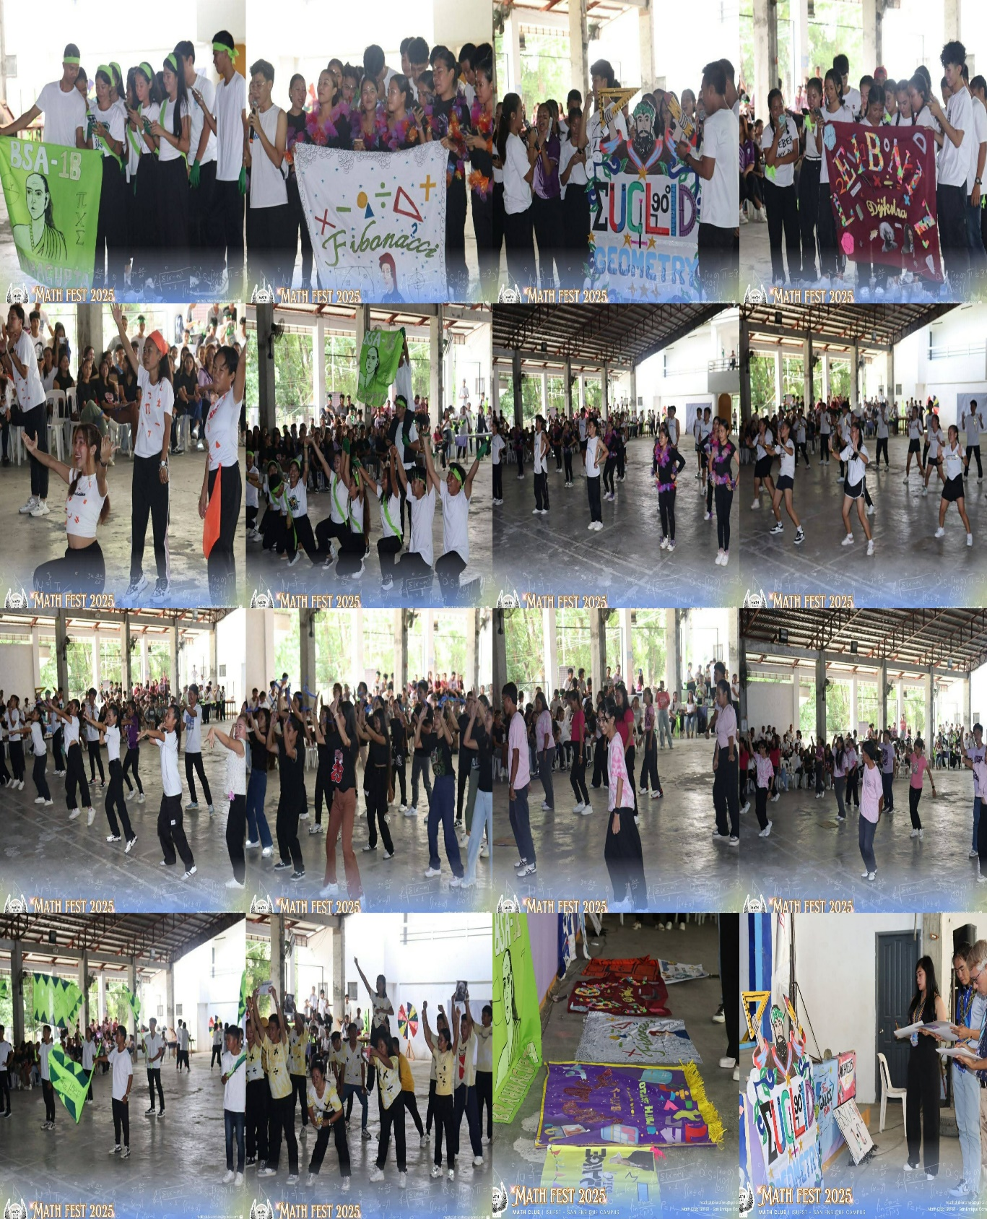**BANNER MAKING, MATH DANCE, AND CHEERS & YELLS CONTEST**

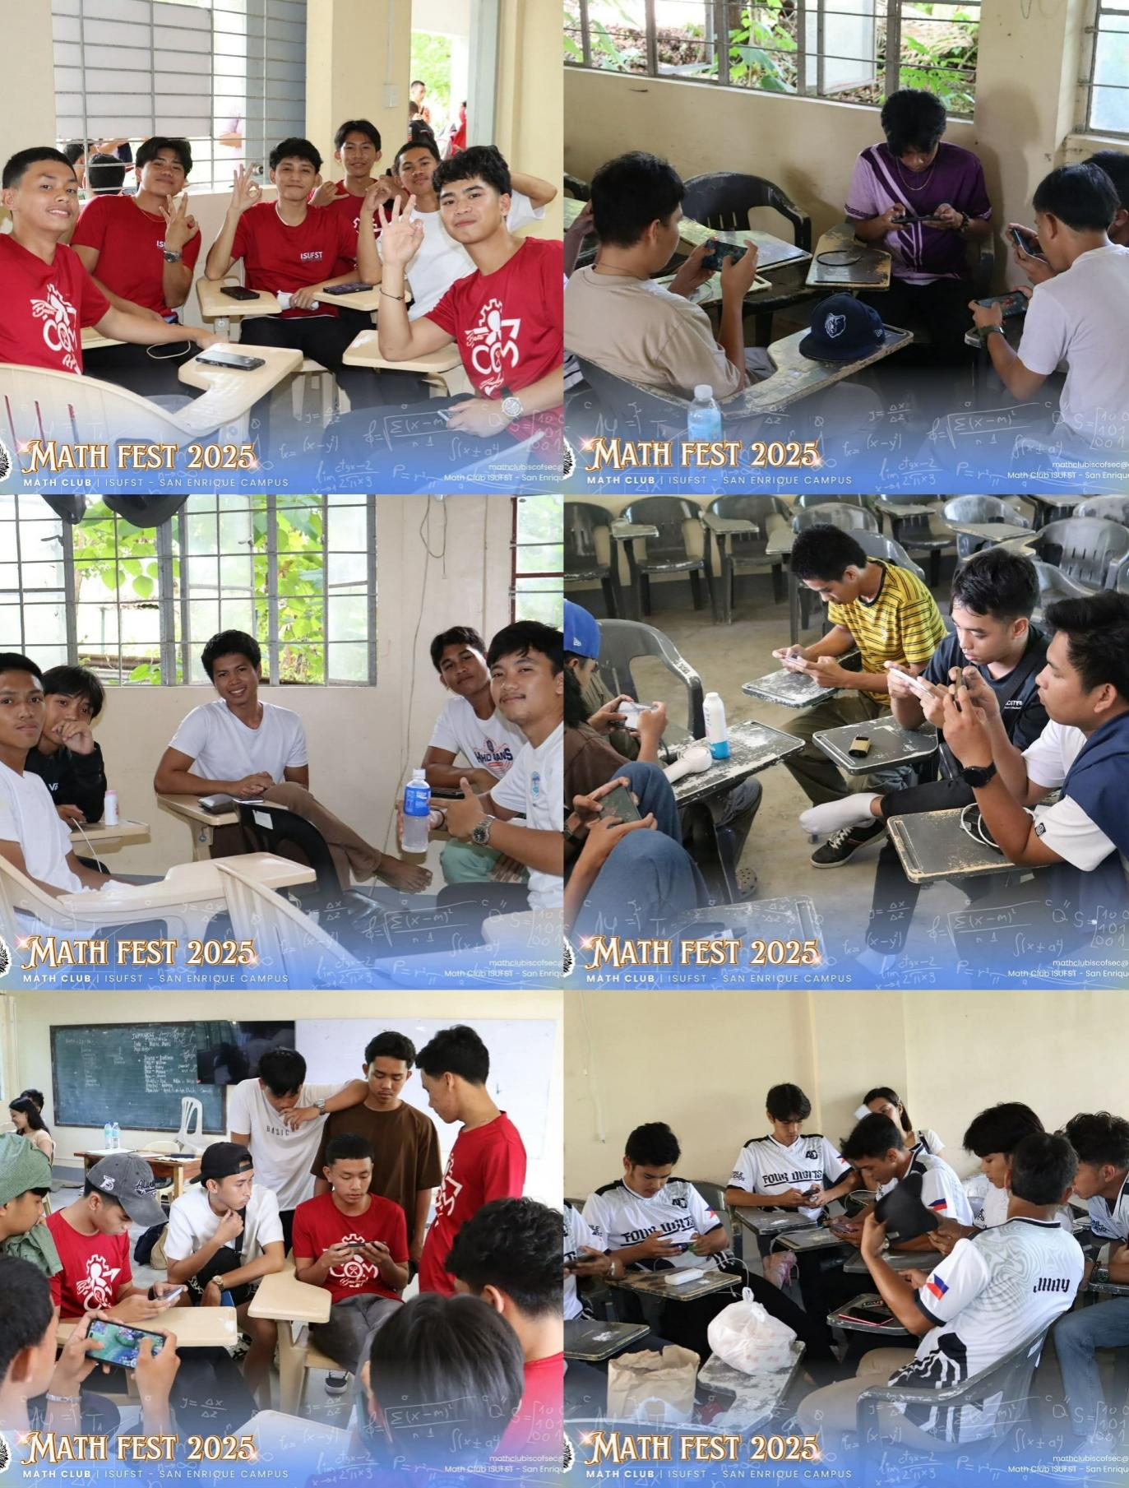**MLBB TOURNAMENT**

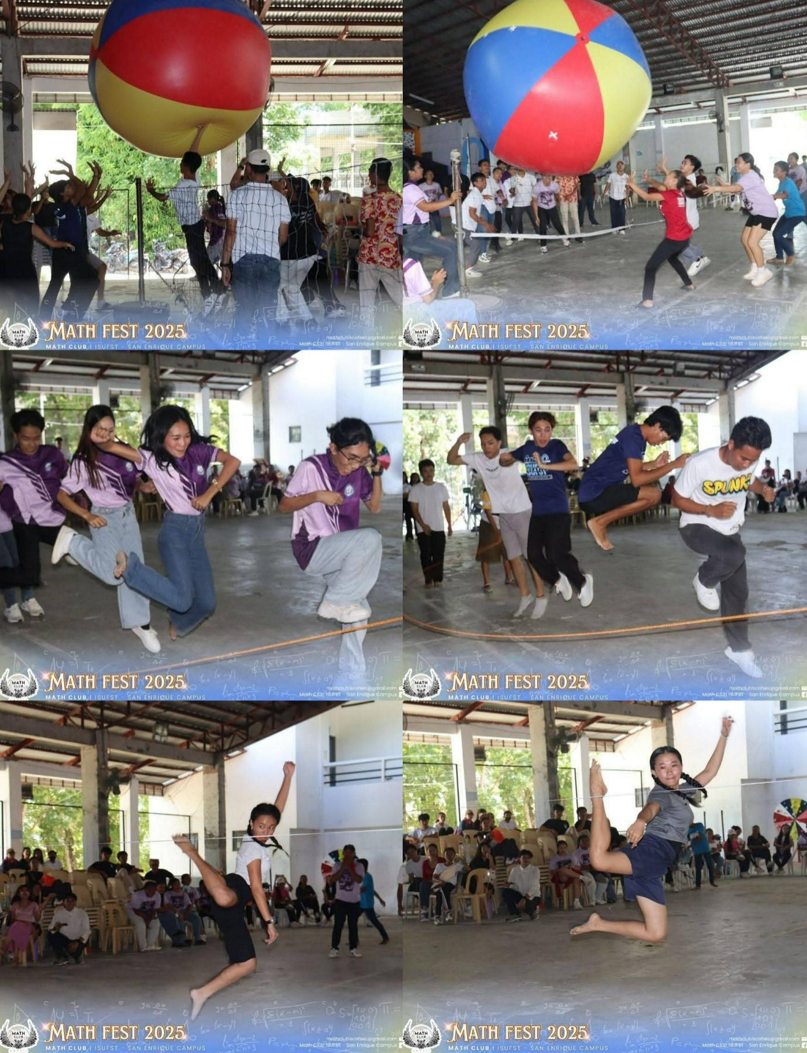**LARO NG LAHI**

**SEARCH FOR MESSTER AND MESS MATHEMATICIAN 2025**

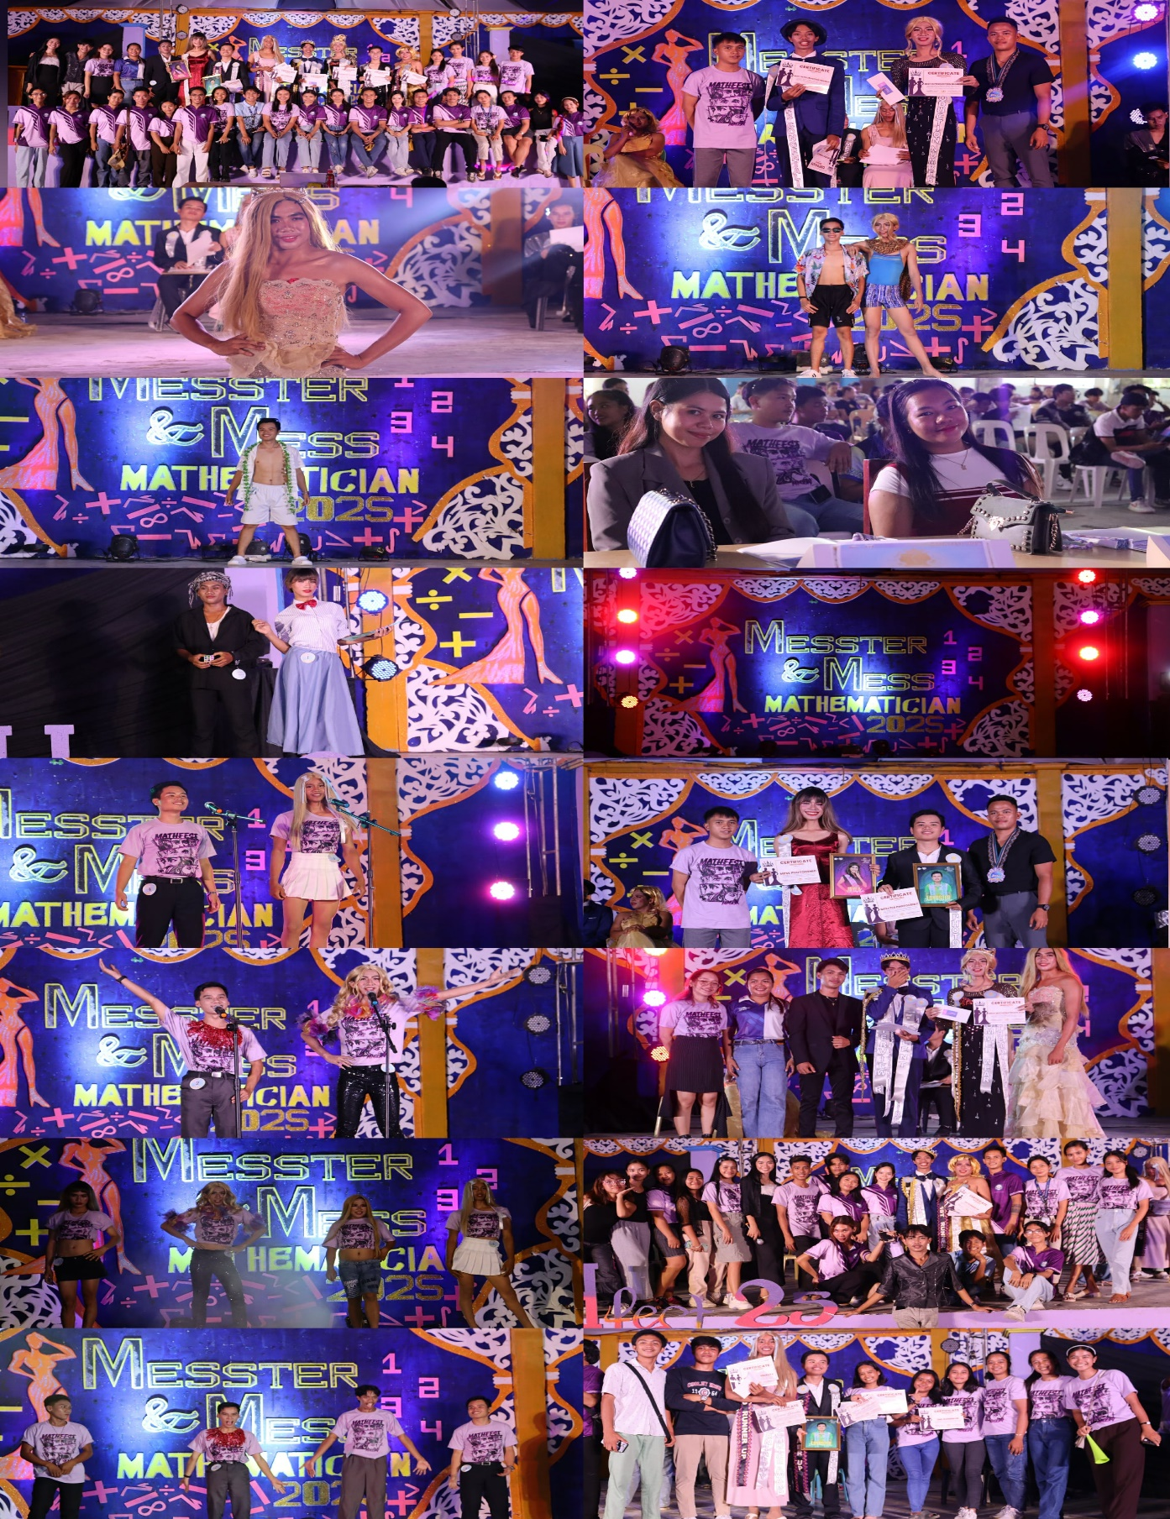

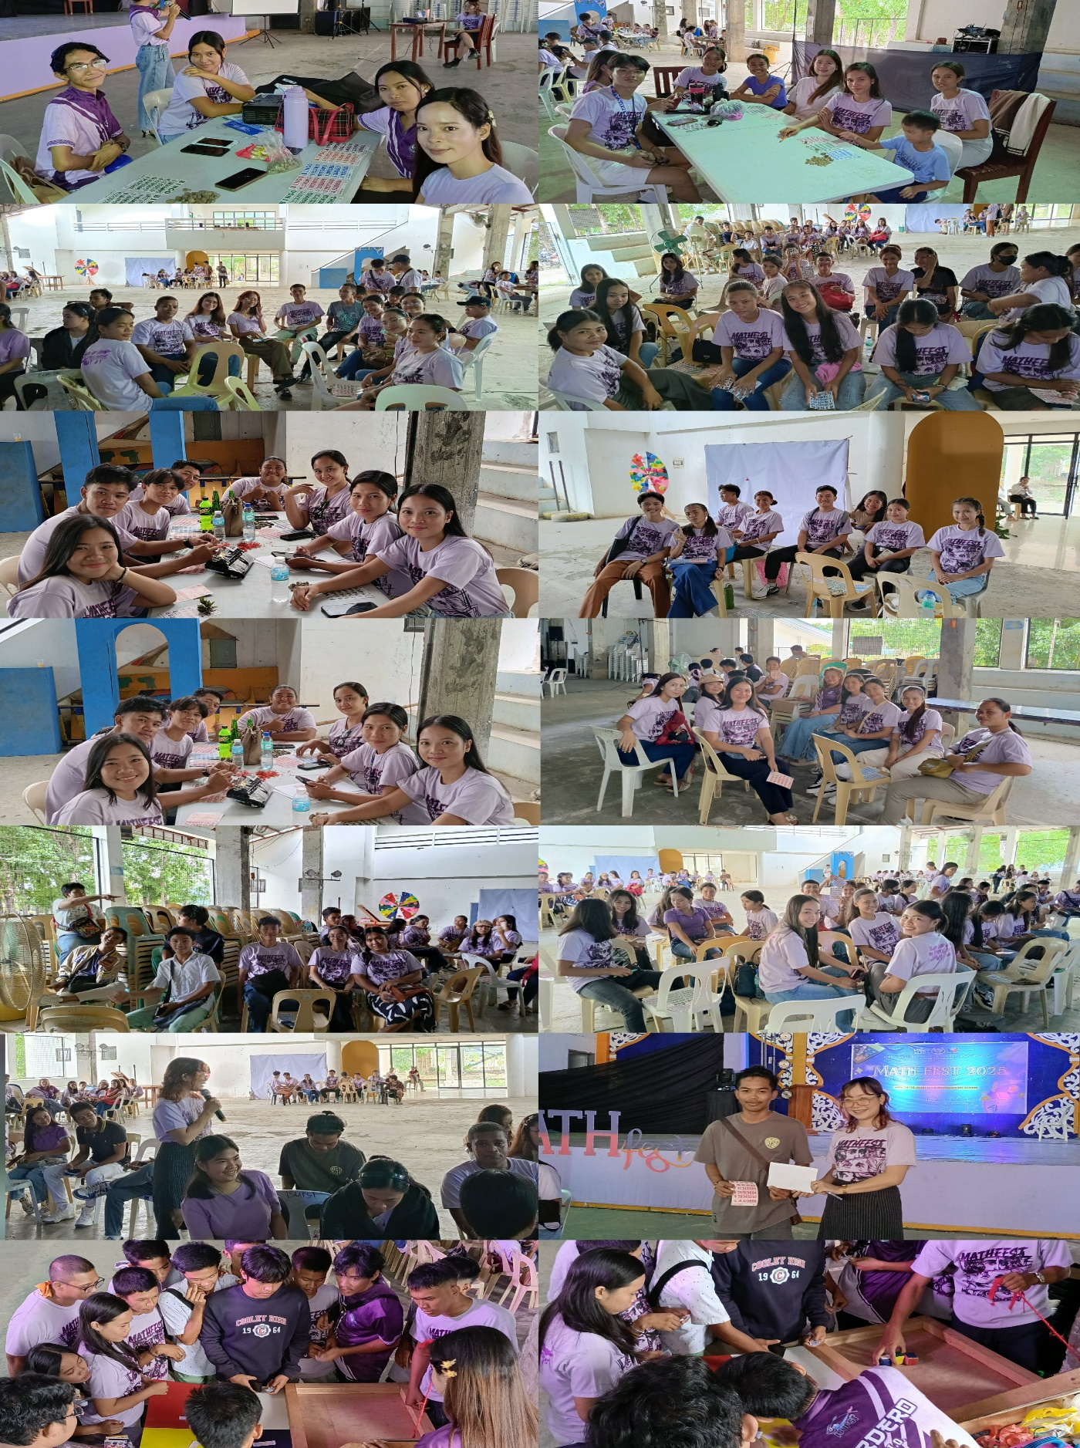**BINGO & COLOR GAMES**

**AWARDING OF WINNERS**

